1. First, we will look at the problem then will see the solution provided by **Spring Boot Starters**.
2. **Problem without Spring Boot Starter**.
   1. Let’s say we want to create Spring MVC Web App.
   2. Graphical user interface, application

      Description automatically generated
3. Solution with Spring Boot Starter Dependency:
   1. 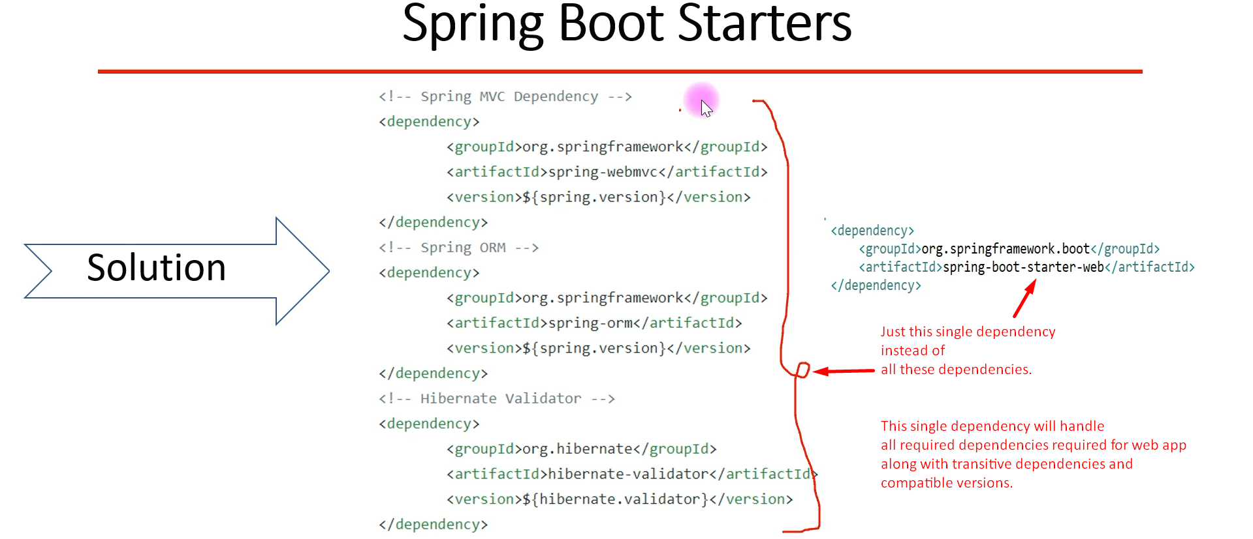
4. Let’s see the inside of Spring Boot Starter.  
   Text

   Description automatically generated  
   A picture containing graphical user interface

   Description automatically generated  
     
     
     
   Graphical user interface, text

   Description automatically generated  
     
     
     
     
   Graphical user interface, text, application

   Description automatically generated
5. Actually, **one Stop Shop** for all the required dependencies along with their compatible versions.
6. Graphical user interface, text

   Description automatically generated with medium confidence